Electrostatics Homework 2 (34 Points)
(jas Electrostatics HW2.docx 10/30/2025)

Use units and clearly label answers using 3 or 4 significant digits where appropriate. Show your work so that if necessary partial credit can be awarded.

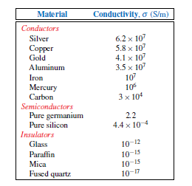
- Using the adjacent table, determine the most likely material of a pure metal solid round wire of 0.644 mm diameter and 1000 meter length for the total resistance values given below:

- 52.9 Ω. (3 points.)
$$σ=\frac{l}{RA}=\frac{1000 m}{(52.9 Ω)(π{\left(\frac{0.644}{2}\right)}^{2})}=5.8*{10}^{7}$$
Copper

- 87.7 Ω. (3 points.)
$$σ=\frac{l}{RA}=\frac{1000 m}{(87.7 Ω)(π{\left(\frac{0.644}{2}\right)}^{2})}=3.4*{10}^{7}$$
Aluminum

- In your own words explain what dielectric permittivity describes or characterizes. (Use complete sentences for your answer). (3 points.)
Dielectric permittivity is the tendency for a material to be polarized when it is in an electric field. When it is subjected to an electric field, the atoms inside it tend to convert to dipoles, meaning that they have noticeable positive and negative sides.

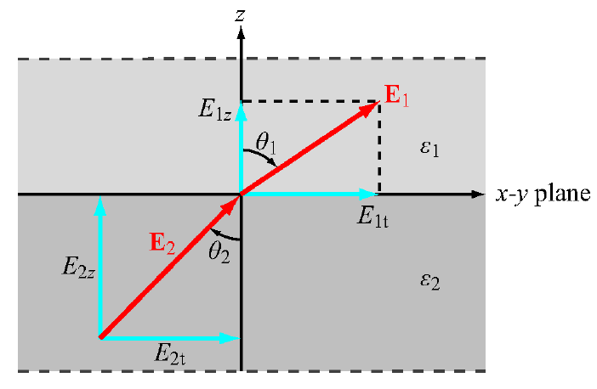
- In the adjacent figure, the x-y plane is a charge free boundary between two different dielectrics. Given $E_{2}=\hat{x}+\hat{y}+\hat{z},$ and ε₂ = 0.7ε₁, find E₁ in V/m (2 points) and θ₁ in degrees (3 points), including units in your answers.
$$tangential:x and y \left(t\right);E_{1x}=E_{2x};E_{1y}=E_{2y}$$
$$normal:z;D_{1z}=D_{2z};ϵ_{2}E_{2z}=ϵ_{1}E_{1z}→ E_{1z}=\frac{ϵ_{2}E_{2z}}{ϵ_{1}}$$
$$E_{1}=\hat{x}E_{2x}+\hat{y}E_{2x}+\frac{\hat{z}ϵ_{2}}{ϵ_{1}}\left(E_{2z}\right)=\hat{x}+\hat{y}+\hat{z}0.7$$
$$E_{1}=\hat{x}+\hat{y}+\hat{z}0.7$$
$$\tan\left(θ_{1}\right)=\frac{E_{1t}}{E_{1z}}=\frac{\sqrt{E_{1x}^{2}+E_{1y}^{2}}}{E_{1z}}=\frac{\sqrt{2}}{0.7}=2.02;\tan^{-1}\left(2.02\right)=θ=63.67°$$
$$θ_{1}=63.67°$$

- In your own words explain physically why the capacitance C increases with decreasing distance between plates for a parallel plate capacitor as described by the formula $C=\frac{ε_{r}ε_{0}\text{A}}{\text{d}} \left(F\right)$. Use complete sentences for your answer. (3 Points.)
Capacitance increases with decreasing distance between the plates because moving the plates closer together creates a stronger electric field between them. This means that there is a larger pull on the charges from the same voltage source, so the capacitor can store more of them. Thus the capacitance of the capacitor is greater for plates closer together.

- In your own words explain physically why the capacitance of a fixed size capacitor increases with increasing relative permittivity ε_{r} of the dielectric between the plates. Use complete sentences for your answer. (3 points.)
Permittivity is the tendency for a material to polarize under an electric field. With an increasing relative permittivity, the material with polarize more, meaning it has a greater positive and negative charge. This means that some of the electric field is canceled out, so the net field from one plate to the other is smaller. The polarized dielectric attracts more charge from the circuit, so the capacitance goes up.

- In your own words explain physically why you cannot change the voltage across a capacitor instantaneously in practical circuits that have nonzero resistances. Use complete sentences for your answer. (3 points.)
You can’t change the voltage across a capacitor instantly because it has voltage inertia. The electric fields inside the capacitor can’t change instantly because of the buildup of charge, which themselves have an electric field. The charge needs to be added or taken away from the capacitor first, which can’t happen instantly. So the voltage must change gradually.

- For an air-filled parallel plate capacitor with a plate spacing of 1 mm, what plate length in meters for square plates is necessary for a 1 F capacitance? (Hint: Answer should be somewhere between 8.0 and 12 km.) (3 Points.)
$$C=ϵ_{r}ϵ_{o}\frac{A}{d}= ϵ_{r}ϵ_{o}\frac{l^{2}}{d}$$
$$l=\sqrt{\frac{Cd}{ϵ_{r}ϵ_{o}}}=\sqrt{\frac{1 F(1*{10}^{3}m)}{(1)(8.85*{10}^{-12}F/m)}}=10.63 km$$
$l=10.63 km$

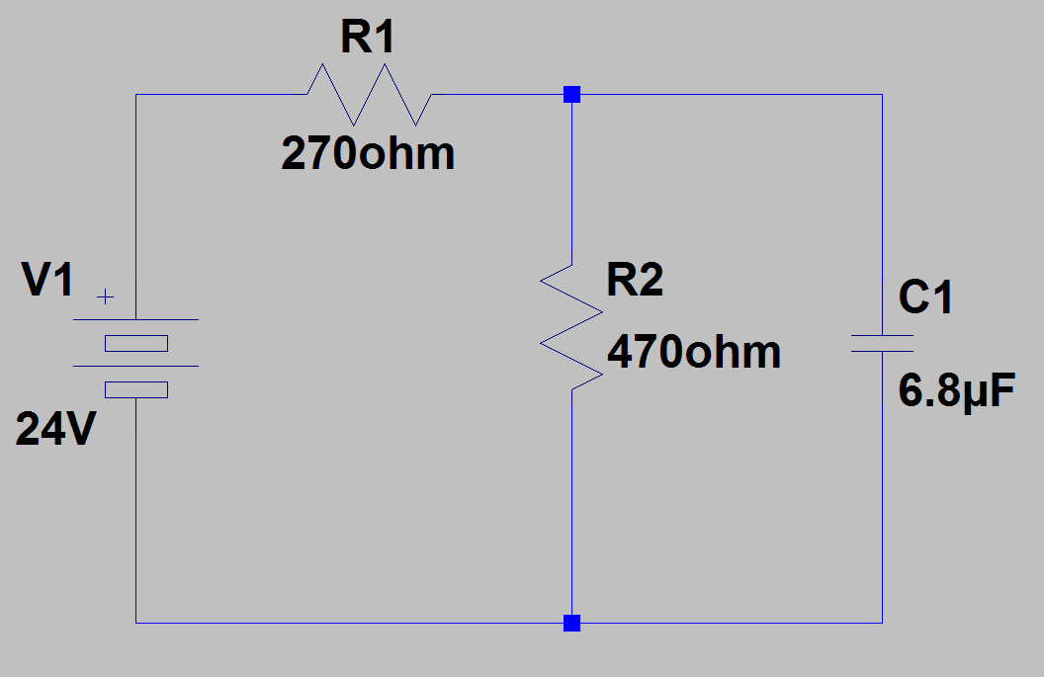
- For the adjacent RC circuit:

- Calculate the separated charge for capacitor C1 in the adjacent circuit. (Hint: Answer should be somewhere between 90 and 120 µC.) (3 Points.)
$$V_{C1}=V_{1}\left(\frac{R_{2}}{R_{1}+R_{2}}\right)=\left(24 V\right)\left(\frac{470 Ω}{270 Ω+470 Ω}\right)=15.24 V$$
$$Q=VC=\left(15.24 V\right)\left(6.8*{10}^{-6}F\right)=103 μC$$
$$Q=103 μC$$

- Calculate the electrical energy stored in capacitor C1 in the above circuit. (2 Points.)
$$W_{e}=\frac{1}{2}CV^{2}=\frac{1}{2}\left(6.8*{10}^{-6} F\right){\left(15.24 V\right)}^{2}=0.79 mJ$$
$$W_{e}=0.79 mJ$$

- Using the formula $C^{'}=\frac{2πε}{ln\left(b/a\right)} \left(F/m\right)$, calculate the capacitance per unit length in (F/m) of a coaxial cable that has the following characteristics: The diameter of the center conductor is 2.7 mm. The inside diameter of the outer conductor is 7.5 mm. The dielectric between the inner conductor and outer conductor has a relative permittivity ε_{r} = 1.6. (Hint: Answer should be somewhere between 80 and 100 pf/m.) (3 Points.)
$$C^{'}=\frac{2πϵ_{r}ϵ_{o}}{\ln\left(\frac{b}{a}\right)}=\frac{2π\left(1.6\right)\left(8.85*{10}^{12}\frac{F}{m}\right)}{\ln\left(\frac{7.5 mm}{2.7 mm}\right)} =87\frac{pF}{m}$$
$$C^{'}=87 pF/m$$

